**Web Designs**

**www.q-infotech.com**

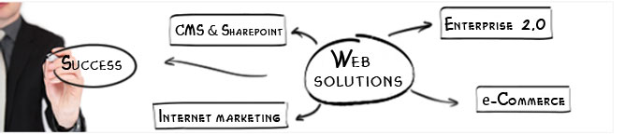

As you may have already guessed, Quick Web Design specialises in web design and Development. We’ve been in business since 2005 and as far as we’re concerned, effective web design isn’t just about you - it’s about your customers too. Our job is to understand the two sides of the story, create a relevant web experience for both, and build a flourishing relationship between you. Like some kind of creative Cupid, you might say.

We can think as big as you need us to, but offer all the speed, flexibility and gratitude of a small agency. There are no layers of bureaucracy to pay for and none for us to hide behind. We’re open, honest and good at what we do.

Steps we take for designing your Website

1. Strategic Business Analysis
2. Concept Development
3. Information Architecture
4. Design Development
5. Technical Development
6. Quality Assurance Testing
7. Deployment
8. Support and Enhancements

Then again, would you expect us to say anything different? So why take our word for it when you can see the kind of thing we do for yourself?